**Faculty Profile s**

1. **Basic Information**

* **Name**: ANOOP KUMAR
* **Designation**: Assistant Professor
* **Department/School**: Mechanical Engineering
* **Institution Name**: Shri Shankaracharya Institute of Professional Management & Technology, Raipur
* **Email ID**:
* **Contact Number**: 7999653573
* **Photograph**: *(Passport-size, professional)*
* 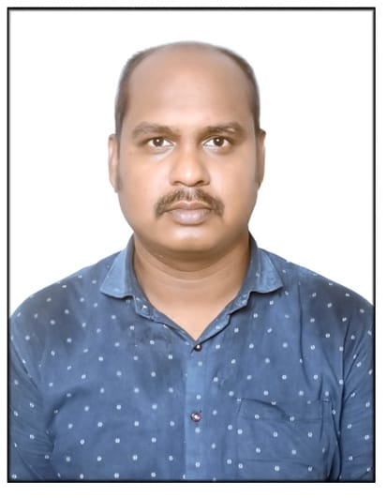

1. **Educational Qualifications**

|  |  |  |  |
| --- | --- | --- | --- |
| **Degree** | **Specialization** | **Institution** | **Year of Completion** |
| UG | Mechanical Engg | RIT, Raipur | 2011 |
| PG | Machine Design | RIT, Raipur | 2014 |
| Ph.D. |  |  |  |
| Others |  |  |  |

1. **Teaching & Research Experience**

* **Total Teaching Experience**: 9 Years
* **Industry Experience**: *(if any)*
* **Research Experience**: Nil

1. **Courses Taught**

* List of key UG/PG courses taught: UG: Engineering Drawing, Machine Drawing, Machine Tool Technology, and Design of Machine Element.

1. **Research Interests / Specialization**

* Vibration, Robotics, Tool Technology

1. **Publications (Last 5 Years)**

* Journals (APA/IEEE format): 02
* Conference Proceedings: 00

1. **Research Guidance**

|  |  |  |
| --- | --- | --- |
| **Level** | **Awarded** | **Ongoing** |
| Ph.D. |  |  |
| PG |  |  |

1. **Awards & Recognitions**

* Institutional / National / International

1. **Administrative Roles**

* Positions held: Head of Department, IIC Convener, IQAC Co-coordinator

1. **Professional Memberships**
2. **Web Presence**

* Personal academic webpage / Google Scholar / ResearchGate / ORCID

Google Scholar:

LinkedIn: